**Experiment 9**

**Aim:** To implement sum of subsets.

**Theory:** The sum of subsets problem is a classic problem in computer science that involves finding all possible subsets of a set of numbers whose sum equals a given target value. Backtracking is a commonly used algorithmic technique to solve this problem efficiently.

In the backtracking approach, the algorithm starts with an empty subset and adds elements to it one by one. At each step, the algorithm checks whether adding the next element to the subset will exceed the target sum. If it does, the algorithm backtracks and tries a different element.

The backtracking approach avoids considering subsets that cannot contribute to the target sum, which improves the efficiency of the algorithm. The sum of subsets problem has applications in various fields, including operations research, finance, and computer science.

**Example:**

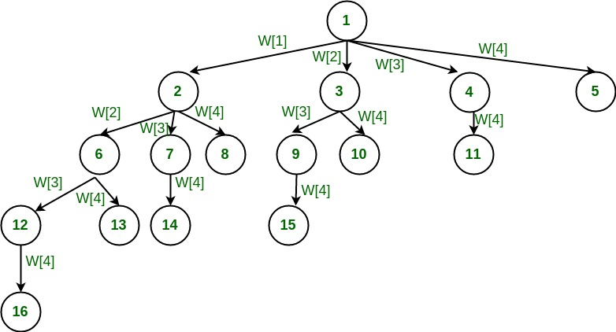

**Algorithm:**

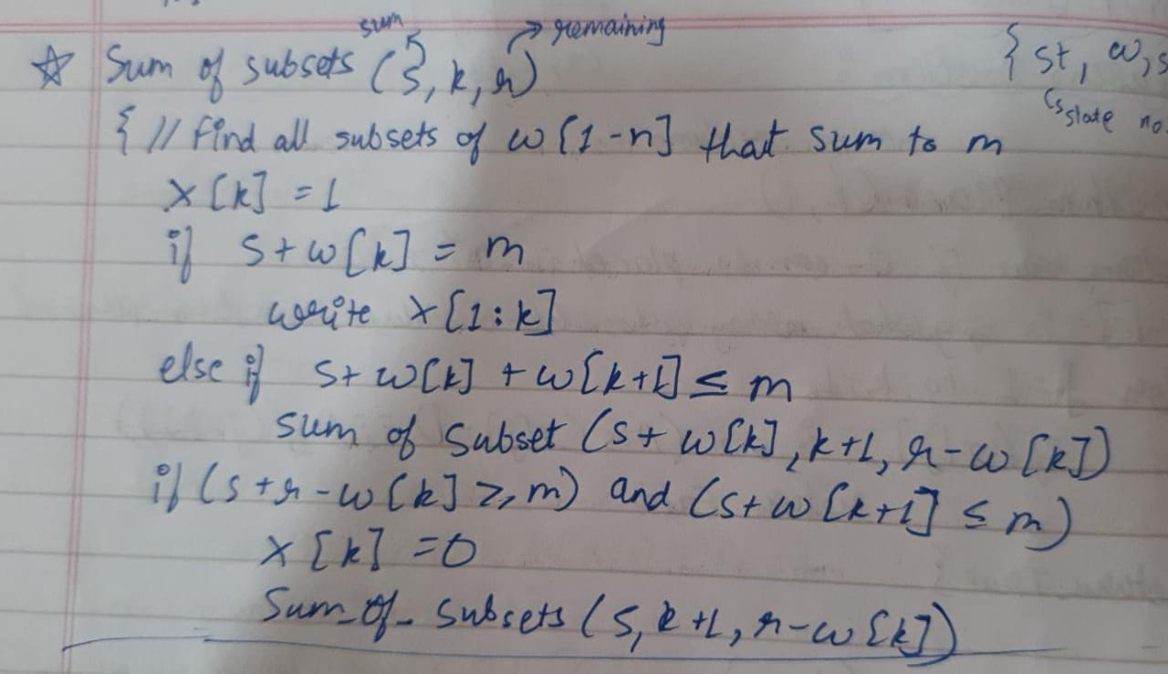

**Code:**

#include <stdio.h>

#include <stdlib.h>

static int total_nodes;

void printValues(int A[], int size){

for (int i = 0; i < size; i++) {

printf("%*d", 5, A[i]);

}

printf("\n");

}

void subset_sum(int s[], int t[], int s_size, int t_size, int sum, int ite, int const target_sum){

total_nodes++;

if (target_sum == sum) {

printValues(t, t_size);

subset_sum(s, t, s_size, t_size - 1, sum - s[ite], ite + 1, target_sum);

return;

}

else {

for (int i = ite; i < s_size; i++) {

t[t_size] = s[i];

subset_sum(s, t, s_size, t_size + 1, sum + s[i], i + 1, target_sum);

}

}

}

void generateSubsets(int s[], int size, int target_sum){

int* tuplet_vector = (int*)malloc(size * sizeof(int));

subset_sum(s, tuplet_vector, size, 0, 0, 0, target_sum);

free(tuplet_vector);

}

int main(){

int set[] = { 7, 6, 12 , 54, 2 , 20 , 15 };

int size = sizeof(set) / sizeof(set[0]);

printf("The set is ");

printValues(set , size);

generateSubsets(set, size, 25);

printf("Total Nodes generated %d\n", total_nodes);

return 0;

}

**Output:**

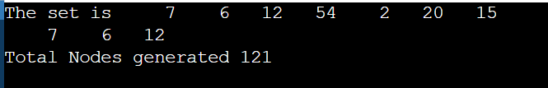

**Conclusion:** Hence we have successfully implemented sum of subsets.